***[Vehicle Hiring System](http://1000projects.org/java-mini-project-on-vehicle-hiring-system.html)***

## **ABSTRACT**

Vehicle hiring system is a web-based application designed to provide the user with an easy way to hire vehicles like cars, buses, vans, lorries etc on rent.  
The customer has to choose the vehicle of his choice, the location where he wants to board the vehicle and pay for the rental online. This application calculates the fare based on three categories short distance, medium distance, and long distance.

## **INTRODUCTION**

Vehicle hiring system is a web application which includes an end user i.e, a customer in which they can make a reservation and view other related information about their reservation.  
The administrator has all authorities to change and manage the system such as adding a new vehicle, removing and updating any related information about the vehicle and keeping track of all vehicle reservations.

## **Existing System**

* The current system does not have wide ranges of vehicles available.
* The customers do not have the facility to give feedback.
* Description of vehicles is less.

## **Proposed System**

* A wide range of vehicles including vans, two-wheelers, buses etc., are available.
* Feedbacks and reviews from the users can be taken.
* A detailed information about the vehicle is available.
* Notification on timings and pickups is available.

## **Modules:**

**ADMIN MODULE:**

Admin can view/edit/delete vehicle and driver details and has authority to view transaction details of the users.

**USER MODULE:**

This module enables the user to Login/ Register, view vehicle details and hire vehicle and perform the transaction.

**Admin Login Details:**

* Step1: Start
* Step2: Login to the account with a unique username and password
* Step3: Choose from the options
* Add vehicle (car/bus/2 wheeler etc.,)
* Add/Delete/update vehicle details
* Step-4: View vehicle reservations of the users
* Step-5: Confirm vehicle reservation and calculate fare based on distance.
* Step-6: Stop

**Customer Login Details:**

* Step1: Start
* Step2: Login to the account with username and password.
* If not registered, register by filling required details.
* Step3: Hire the vehicle and enter details such as date, duration, and boarding location.
* Step4: Confirm the reservation.
* Step5: View bill and make payment.
* Step6: Stop

**Flow Chart:**

[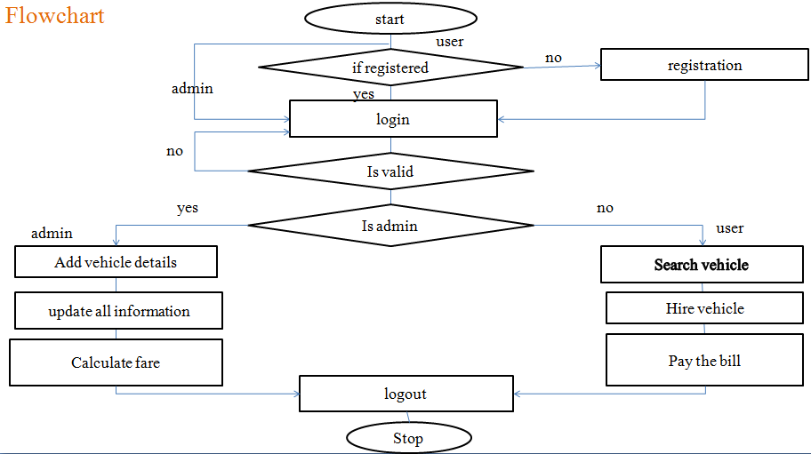](http://1000projects.org/wp-content/uploads/2018/10/Vehicle-Hiring-System-Flowchart.png)

***ER Diagram:***

[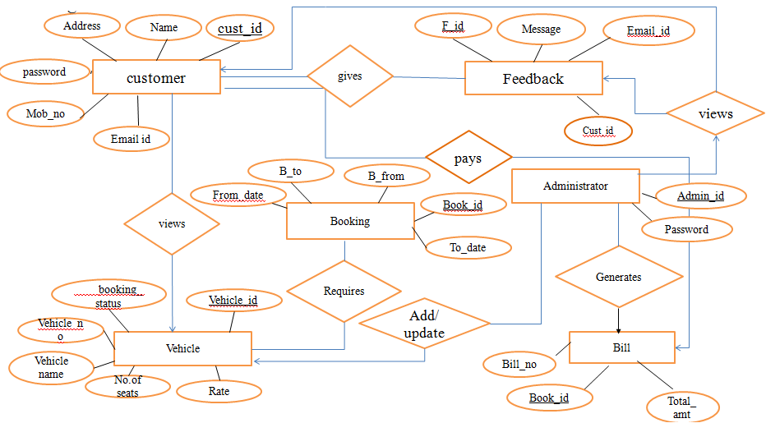](http://1000projects.org/wp-content/uploads/2018/10/Vehicle-Hiring-System-ER-Diagram.png)

Sequence Diagram:

[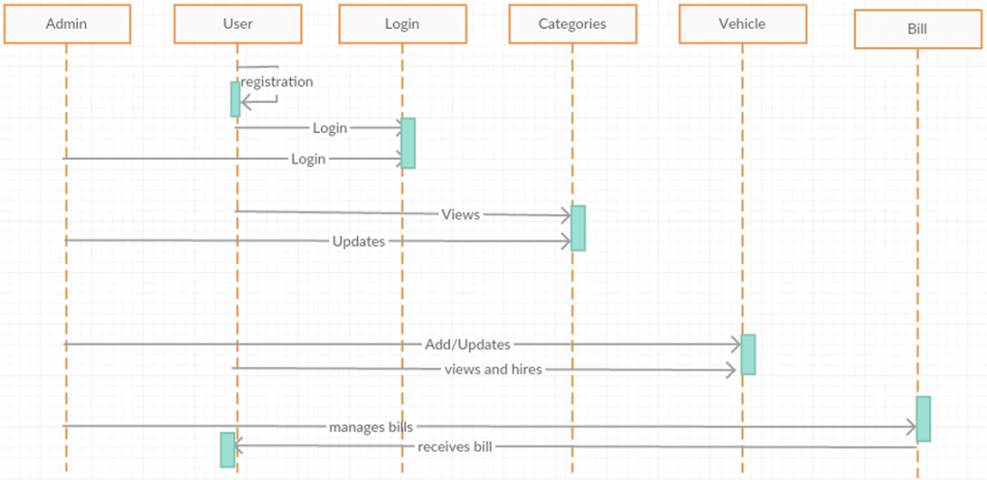](http://1000projects.org/wp-content/uploads/2018/10/Vehicle-Hiring-System-Sequence-Diagram.png)

Collaboration Diagram:

[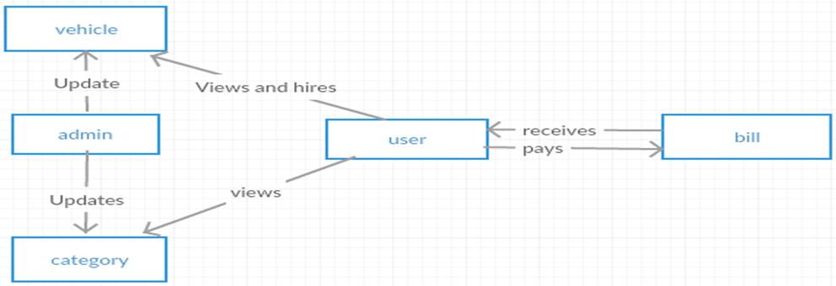](http://1000projects.org/wp-content/uploads/2018/10/Vehicle-Hiring-System-Collaboration-Diagram.png)

**DATA FLOW DIAGRAM:**

[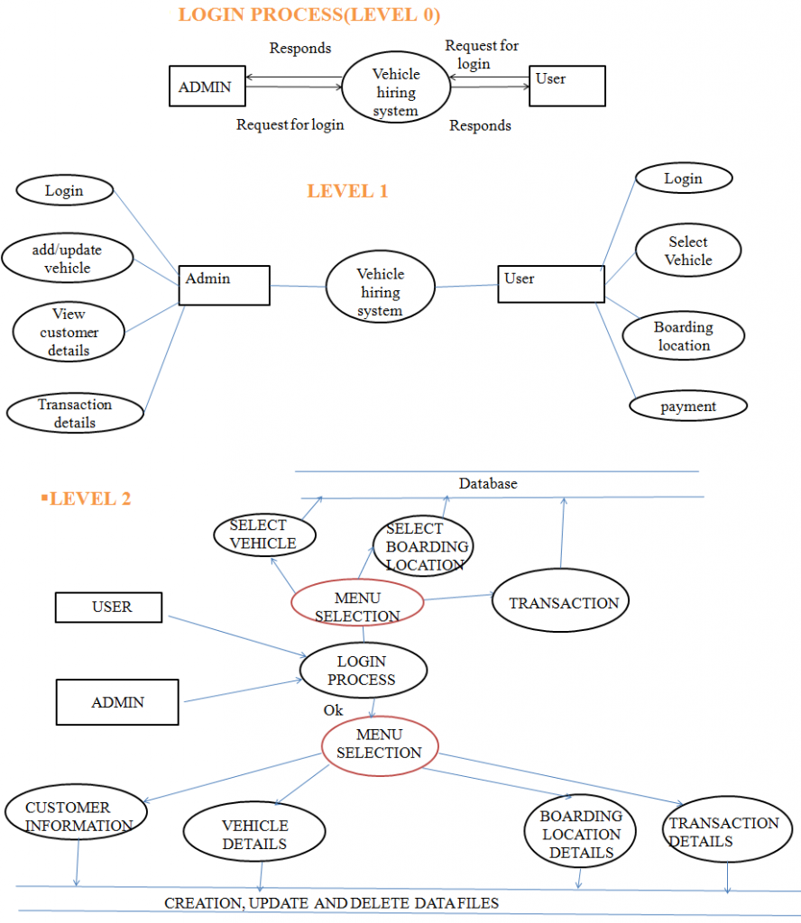](http://1000projects.org/wp-content/uploads/2018/10/Vehicle-Hiring-System-DataFlow-Diagram.png)

***Admin Table***

* admin_id number(32),
* name varchar2(256),
* email_id varchar2(256),
* constraint pk_admin primary key(admin_id)

***Vehicle Table***

* vehicle_id number(10),license_no varchar(20),model varchar(20),
* status varchar(20),
* drate number(10),
* Status varchar2(20),
* constraint pk_vehicle123 primary key (vehicle_id),
* unique (license_no)

***Customer Table***

* c_id number(32),
* name varchar2(256),
* email varchar2(256)
* address varchar2(256),constraint pk_customer123 primary key(c_id)

**Feedback Table**

* fid number(10) not null ,
* message varchar(140),
* email varchar(50),customer_id number(10),
* constraint pk_feedback primary key (fid),constraint fk_feedback foreign key(c_id) references
* customer(c_id)

***HIRE Table***

* hid number(10) not null ,
* hdate date,
* amount number(10),
* vehicle_id number(10),
* constraint fk_hire primary key (hid),
* constraint fk_hire foreign key (vehicle_id) references vehicle123(vehicle_id)

***BILL Table***

* bno number(10) not null,
* bdate date,
* Famount number(10),
* hid number(10),
* Constraint pk_bill primary key (bno),
* constraint fk_bill foreign key (hid) references hire(hid)